Name: _________________
Date: ______________
CLOUD COVER
Identify: Use the word bank to identify each description.
Meteorologist 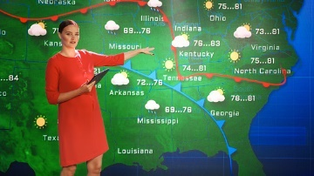 | Clear | Scattered | Sunburn
Temperature | Visibility | Dust | Forecast

_______________ 1. The ability to see something clearly.
_______________ 2. A person who studies and predicts weather.
_______________ 3. When the sky has no, or few, clouds.
_______________ 4. Skin condition from being out in the sun.
_______________ 5. Guess what the weather will be like.
_______________ 6. When up to half of the sky is filled with clouds
_______________ 7. How hot or cold it is outside.
_______________ 8. Can cover the sky.

Multiple Choice: Choose the best answer.
9. Why do clouds make it warmer at night?
A. They shield the earth from the hot sun.
B. They keep heat close to the earth.
C. They block the heat.
10. What does the sky look like when it is cloudy?
A. It is covered by clouds.
B. The sunny, blue sky shows through.
C. A few clouds in the blue sky.

Additional things to know about clouds in the sky:
Types – there are many ways the clouds cover the sky.
Scattered – clouds cover half of the sky.
Mostly cloudy – clouds cover more than half of the sky.
Overcast – clouds fully cover the sky.
Precipitation - water in the sky, in the form of rain or snow.
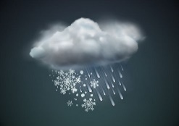
Visibility – the ability to see clearly
Obscure – when fog, snow or dust makes it hard to see the sky
Low visibility – when the cloud cover is difficult to see
